Lab 1 Design Document

Hardware:

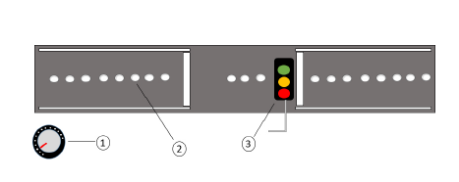

1. Potentiometer
2. LEDs
3. Traffic light
4. Shift Registers x3

Shift Registers

* We have 3 8-bit shift registers. Each register needs 1 clock and 1 data input. Each 8-bit can output and control 8 LEDs at a time.
* We need the shift registers because there are not enough GPIO pins to control all LEDs.
* If we stack the shift registers in parallel, then we only need 1 clock input and 1 data input for all of them. This means we only need 1 data value input to update all the LEDs at once.

Middleware

|  |  |
| --- | --- |
| Adc_func | LED controller |
| -reads analog from potentiometer  - returns digital value | - accepts input  - updates LED shift register |

Software / Application layer

|  |  |  |  |
| --- | --- | --- | --- |
| Traffic flow task | Traffic Generator Task | Traffic light state task | System Display Task |
| * Continually reads from potentiometer via adc_func. * If val is high, push heavy onto Queue * Else if val is low, push low onto Queue. * Else, push 0 onto Q. | * Reads from traffic flow Queue. * If val is high, set traffic to high * Else if val is low, set traffic to low * Else, set traffic to 0 * Event flag – set to high, low, 0 -> 2, 1, 0. | * Reads event flag from Traffic Generator Task. * If high, green light duration high. Red light duration low. * Else if low, red light duration high. Green light duration low. * Else, Green light duration 0. Red light duration infinity. * Use timer to change lights.   (Need 3 for different lights.) | * Reads event flag from Traffic Generator Task. * If high, send cars out at high rate. * Else if low, send cars at low rate. * Else, send no cars. |